Schedule Management Plan
RAM-IT: ITRO’s Chatbot and Ticketing System

Asia Pacific College
3 Humabon Place, Magallanes
Makati City 1232 Philippines

may 3, 2023

Table of Contents
Introduction 2
Schedule Management Approach 2
Schedule Control 3
Schedule Changes and Thresholds 5
Scope Change 5

Introduction

For every project that will be created or built, there is always a record of the time and where the deliverables are placed. Deliverables that are either to be started, ongoing, and complete, here thus also lie the plans for the future of the projects which in the case of a technological project is called either update or upgrade.

The Schedule Management Plan is technically one of the most important aspects of planning to create a program where it records and even lists deadlines for each part of the project. The purpose of the schedule management plan for technological projects is to complete a specific program in order and thus monitor the insights of the developers in the first place are thoroughly followed.

Schedule Management Approach

There is a software called Project Libre, it was introduced and taught to the developers of the project. In Project Libre, the developers list, plans out, and monitor the parts of the project that moves the progress of building the program.

The said software helps the team to approach the schedule management plan. The developers include a specific format to be easily understood which reviews the progress now and then. This software also indicates the milestones of the project, which under these milestones are deliverables of each member that records the progress, roles, and responsibilities.

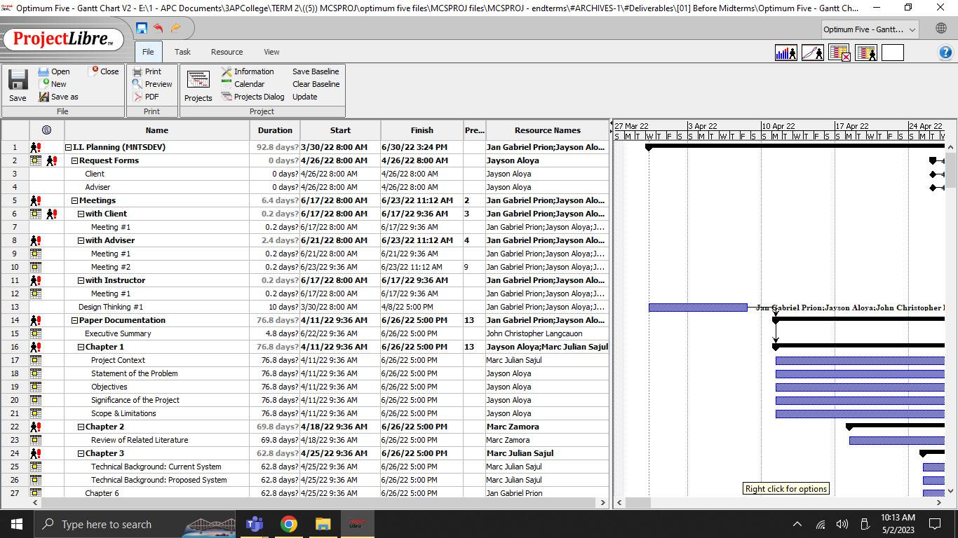

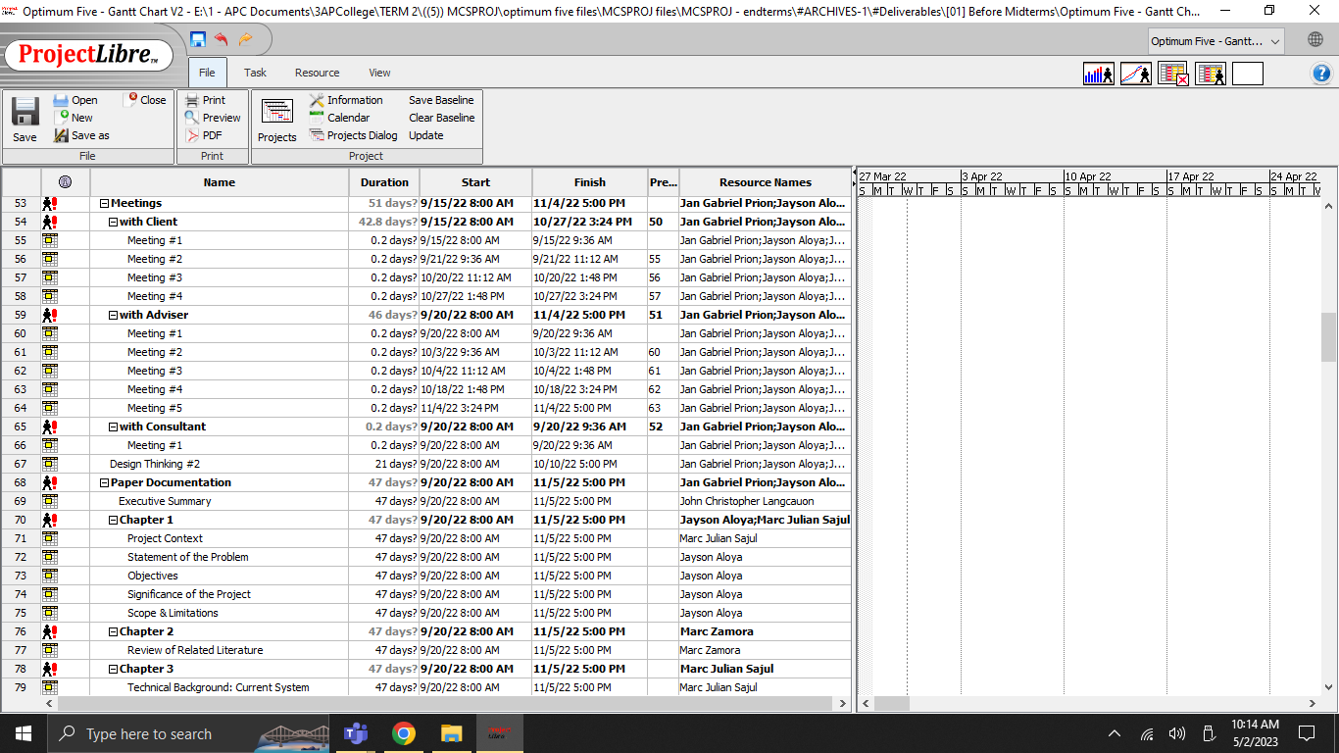

Schedule Control

With the help of how the developers approached the schedule management plan, the team was able to put the management under control. The team was able to control schedule management not only with the said application but also with the help of Microsoft Teams. Microsoft Teams reminds the members about meetings that tackle the listed plan in the team's Project Libre.

For the communication and updates that control, and follow the flow of the plan for the project. Microsoft Teams is effective and efficient, and with its Calendar, the team meetings are reminded. Communicating with the team helps the members with their deliverables and deadlines. With this kind of control, it will be easy for the team to be notified if the project has a minor or major update will be added to the project.

Group or Team meetings are important not only for brainstorming and communicating about the project but also this reminds the team about the schedule management plan of the project.

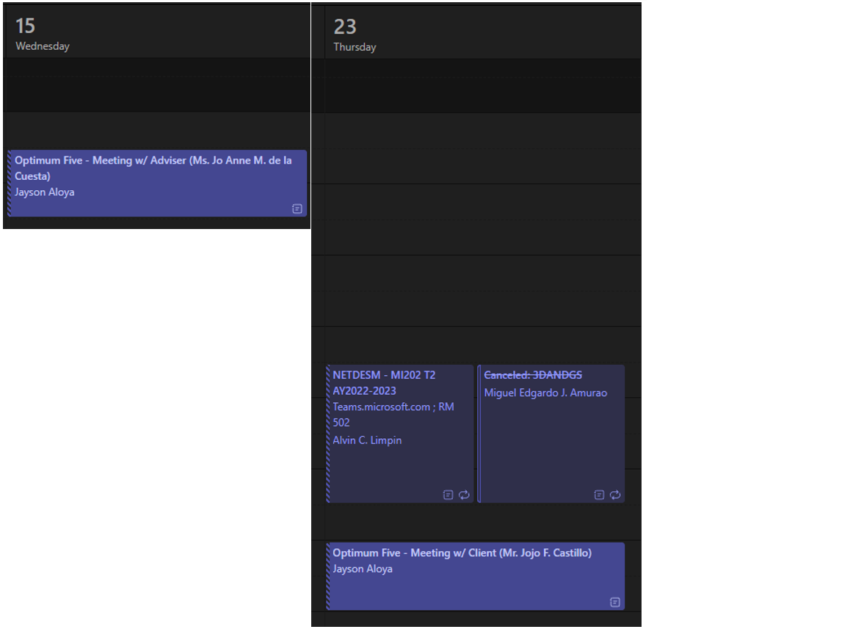

Schedule Changes and Thresholds

As for the team's development progress, there is a consistent and planned schedule since each member of the team must be updated on little by little progress of each work. The team expects that at any time in the progress, there will be multiple circumstances of schedule changes and the deliverables or project thresholds.

For the team to comply with these kinds of situations, we do not set or stack up the contents and the lists of deliverables from the schedule management plan for that it would be possible and still on track and thus maintain the consistency of the progress of the project if there will be changes from the schedules of each member, deliverables and the deadlines that can also affect the threshold which if managed well, the team will not have a hard time to re-adjust.

The team allotted more or less 42% per week to comply with these circumstances, which will create a more or less 33% change in the threshold for the monthly deliverable or milestone of the project.

Scope Change

The given allotted dates, times, or days in the team's schedule management plan will not ruin the plan if a change will occur during the progress. It will be less workload for the team and its project manager to readjust or re-baselined the schedule management plan.

The team consists of a few members, so assigning more deliverables for each day would stack up and may end in confusion or forgetting about the assigned deliverables, it will create havoc within the schedule management plan, depending on the change that will occur.

The proper management and setting of the schedule management plan will affect the developers, the team, and the project manager that oversees the progress from time to time. It will be easier to monitor, adjust and add if there will be changes within the plan.

Sponsor Acceptance

Approved by the Project Sponsor:

Date:
<Project Sponsor>
<Project Sponsor Title>

This free Project Schedule Management Plan Template is brought to you by www.ProjectManagementDocs.com

